**Excel Task on Amazon Pantry**

Q1) Create a bar graph showing the sales. Label the chart correctly so that senior management gets a clear report of sales.

Ans) The below mentioned is the bar graph showing the sales

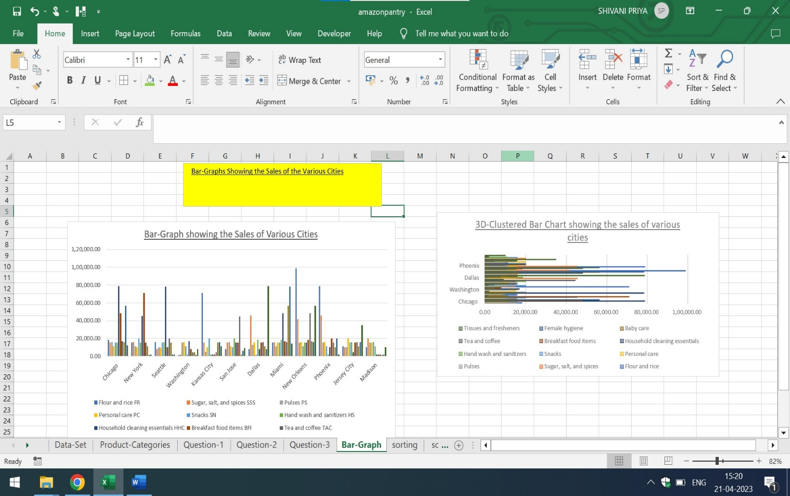

Q1-2) Arrange the data above in excel in ascending and descending order.

Ans) The below mentioned is the data in ascending order:

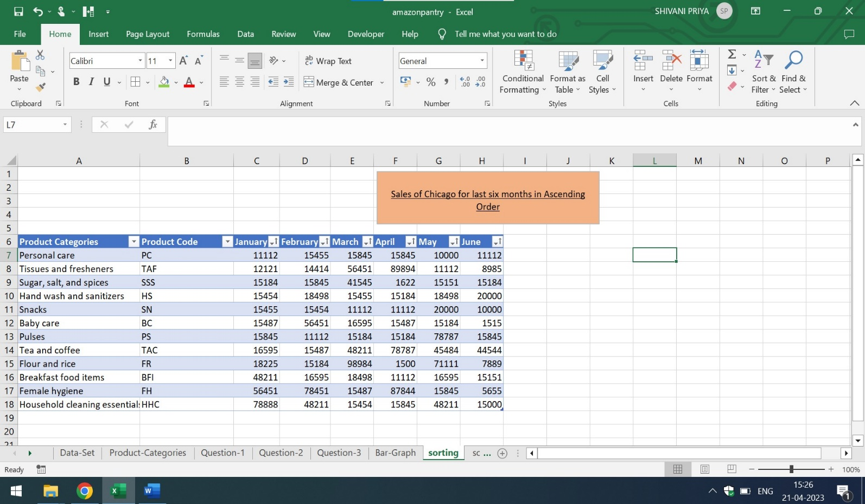

The below mentioned is the data in descending order

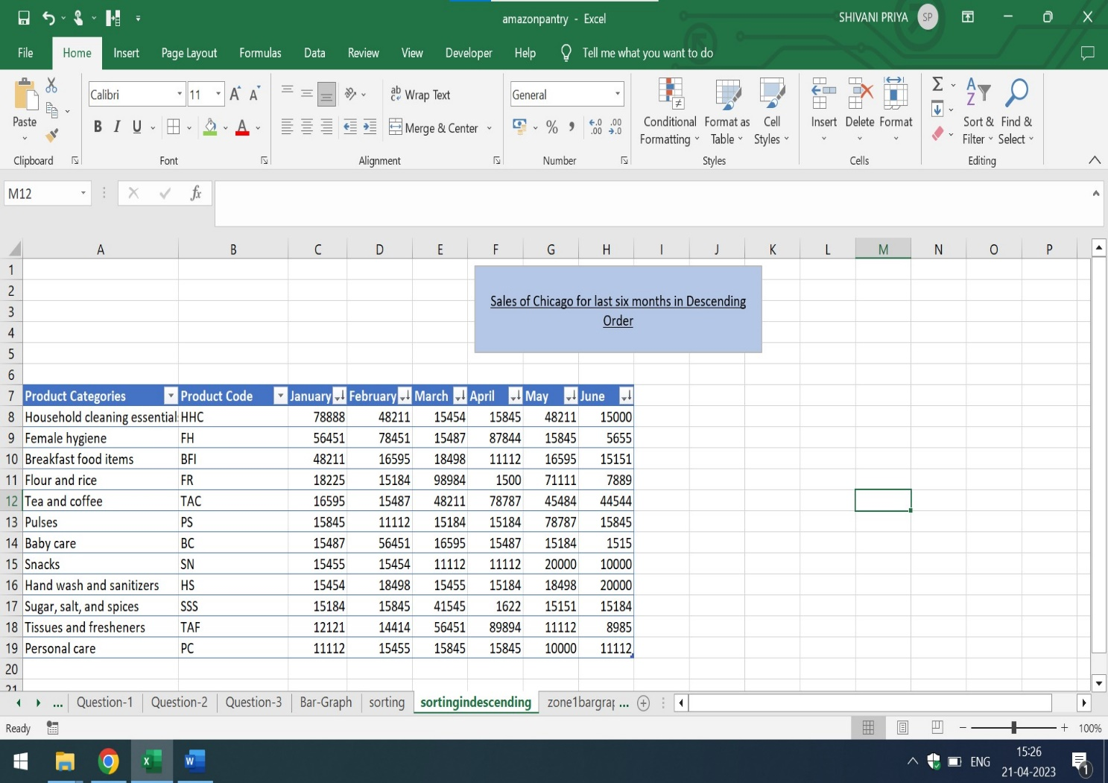

**Question-2**

1. Create bar graphs of sales for zone1 cities

Ans) The bar graphs of sales for zone 1 cities is mentioned below:

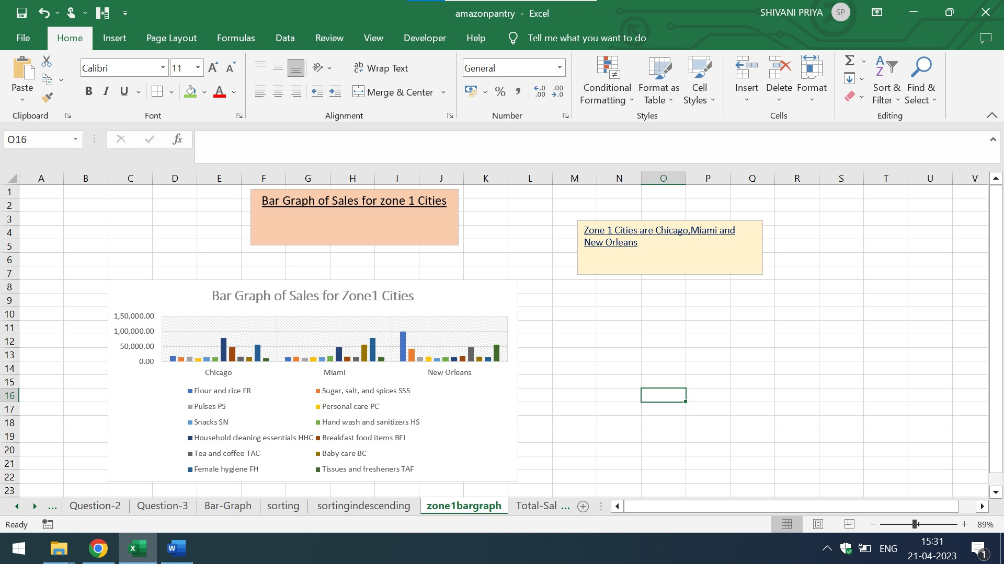

Here,the Zone1 Cities are Chicago,Miami and New Orleans

Q2) Find total sales across all cities

Ans) The total sales across all cities is mentioned below:

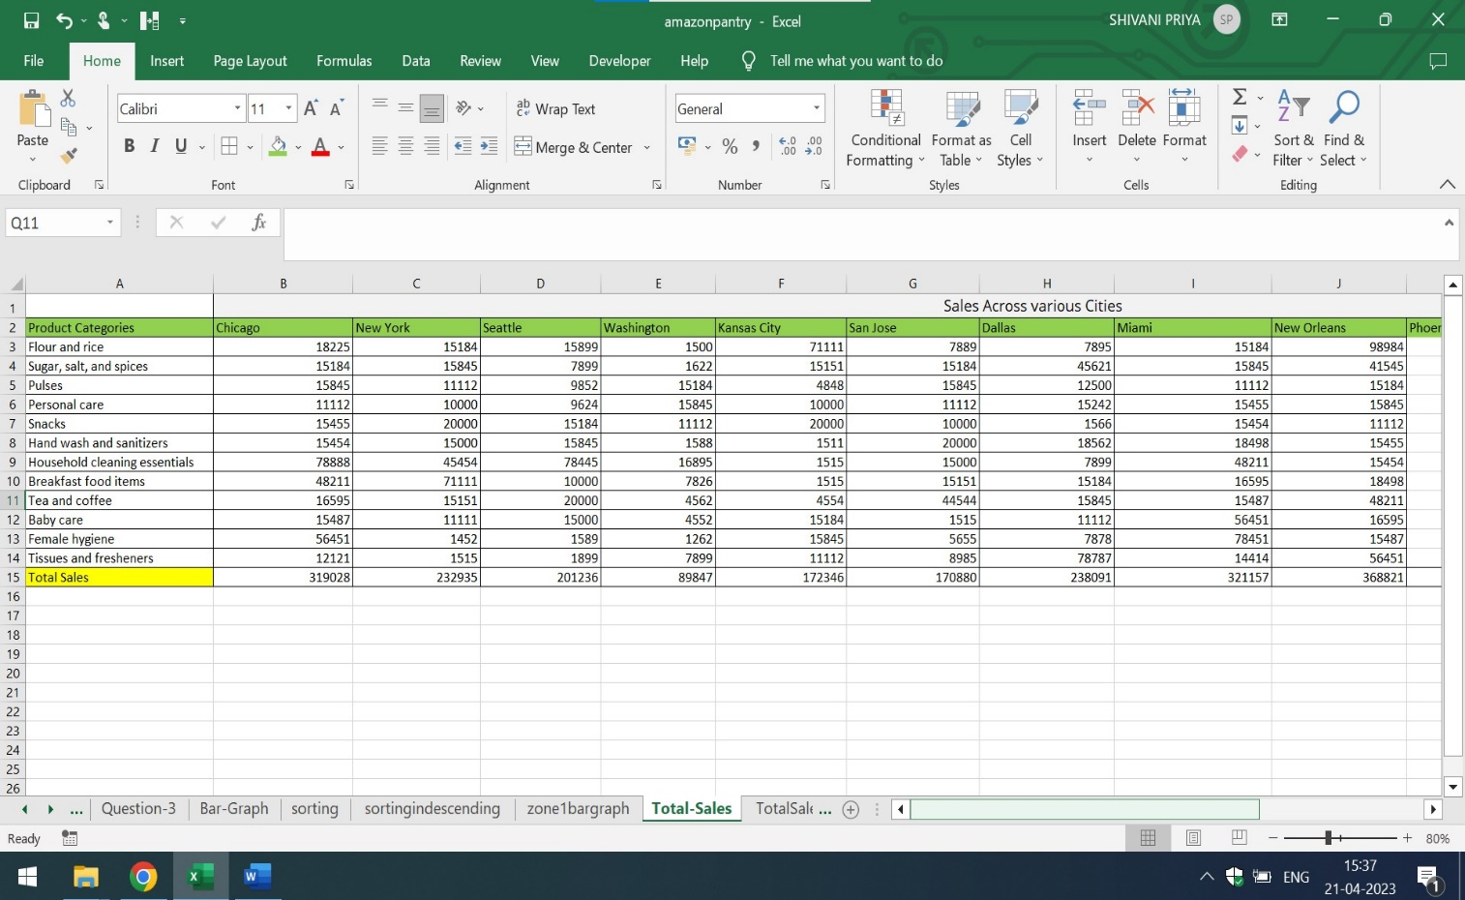

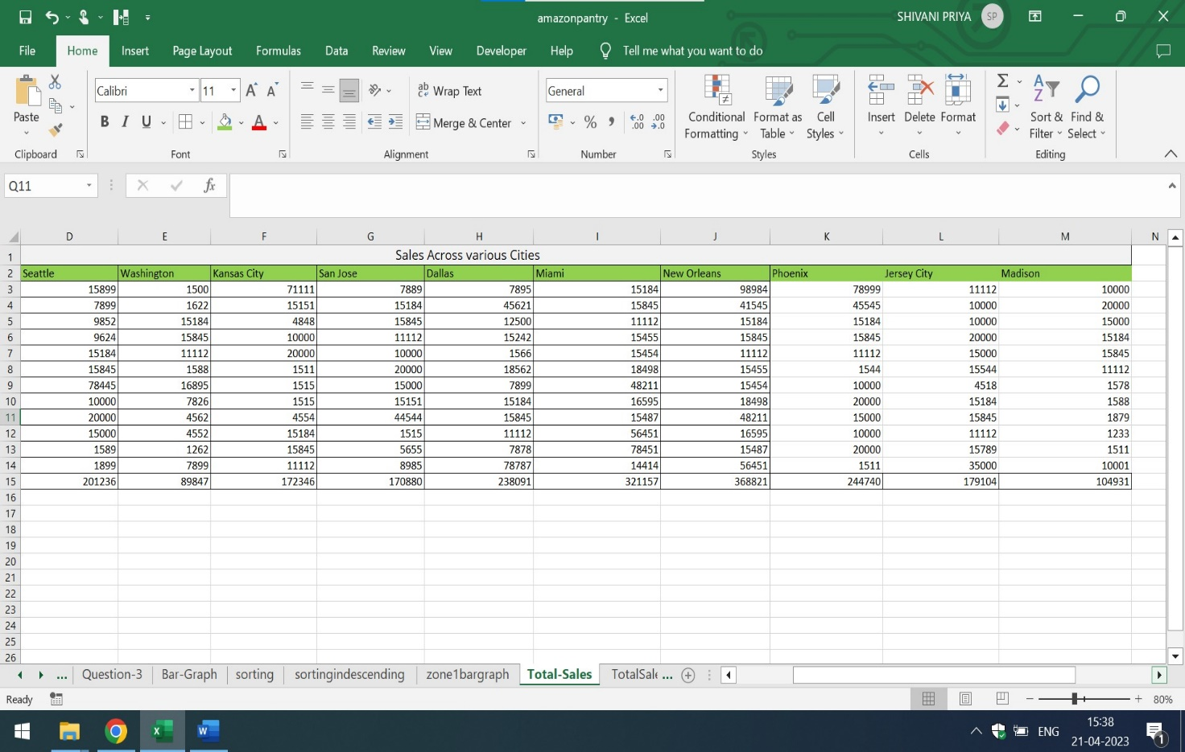

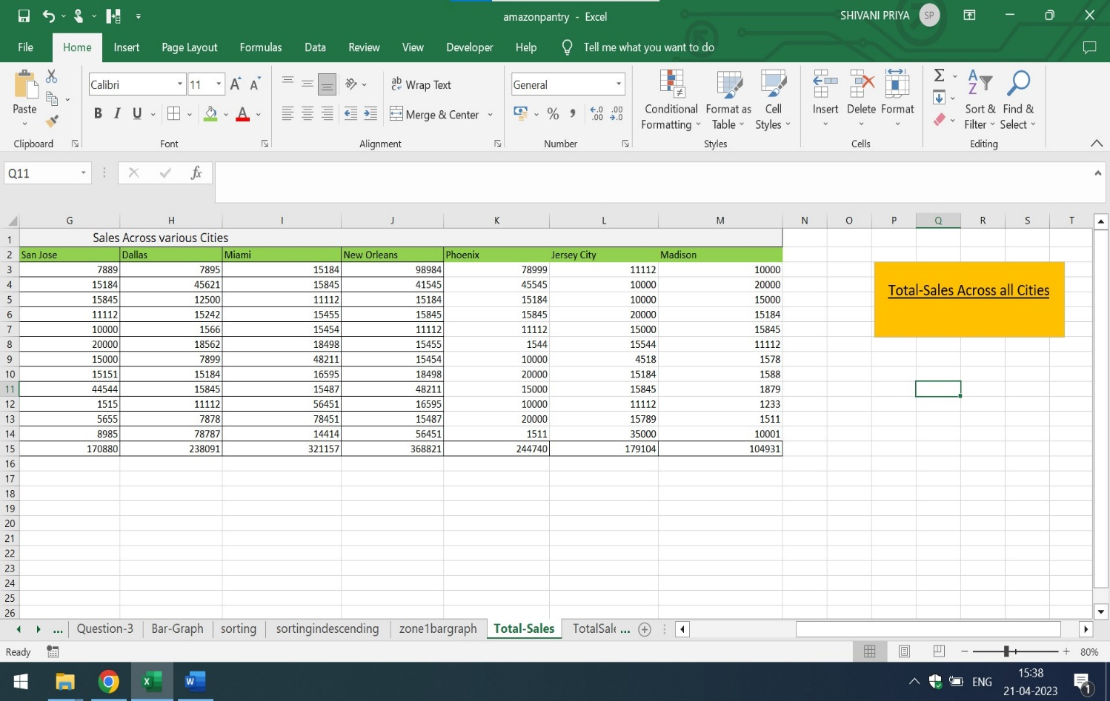

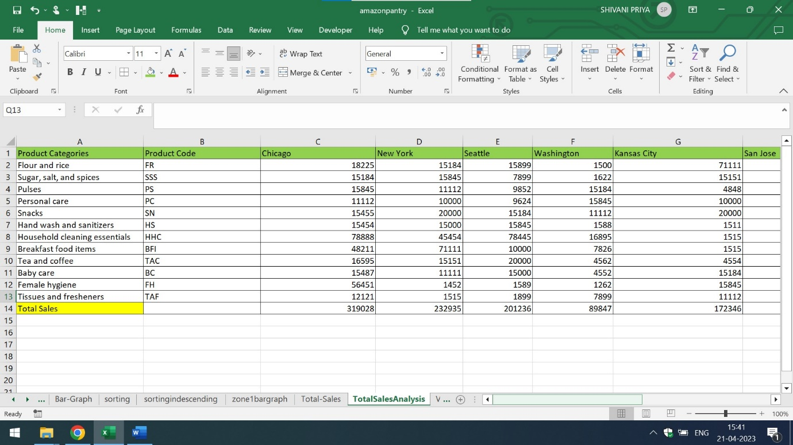

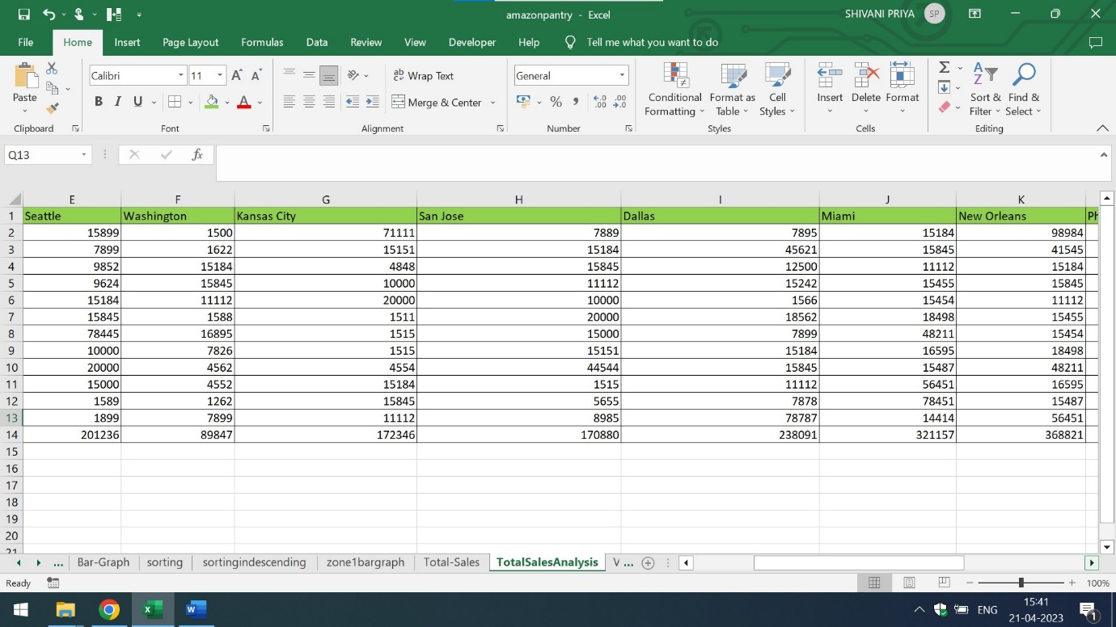

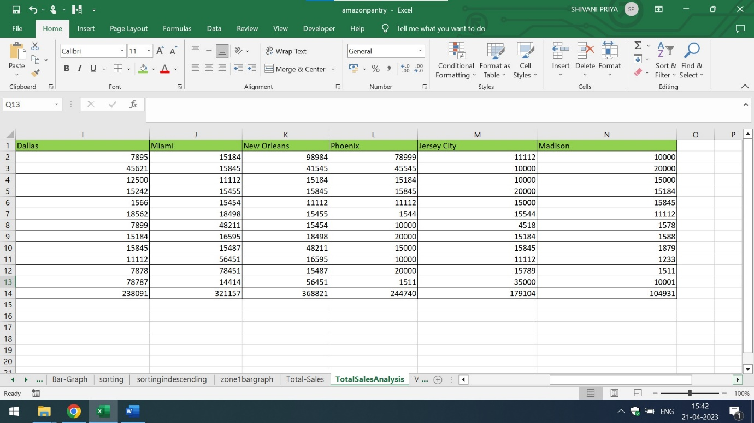

**Question-3**

1. Using vlookup for product code HS, find sales in Phoenix
2. Using vlookup for product code FR, find sales in Dallas

Ans) The sales in Phoenix and in Dallas for Product codes HS and FR are mentioned below:

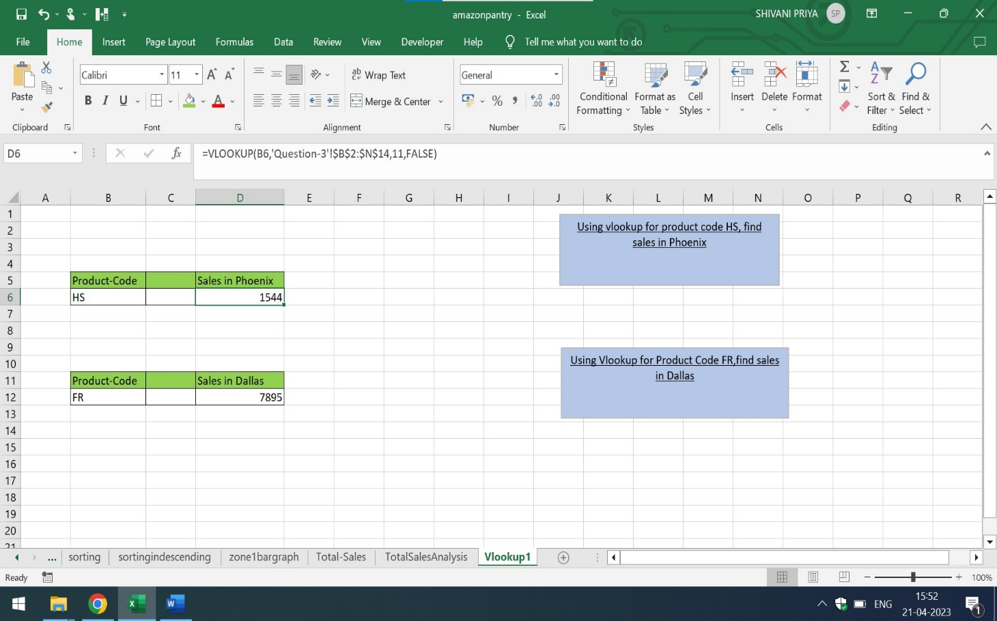

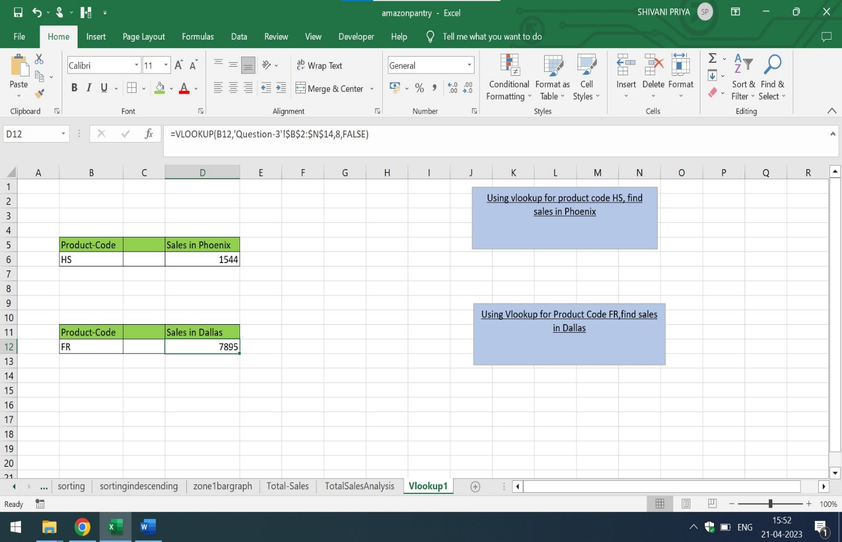

For detailed description and explanation of Amazon Pantry Project in Excel,click on the below mentioned link:

<https://github.com/shivanipriya89/Amazon-Pantry>

It has amazonpantry.xlsx file for download